Solutions for Midterm 2

# Multiple Choice

1. Suppose that we create an empty hash table, then insert n integers into the table using chaining. What is the expected time complexity of this entire process?  
   B. Expected O(N)   
   [this one was #3 on exam]
2. If for a given hash function H, one can find in less than a minute two distinct values with the same hash value: x=/= y, yet H(x) = H(y) then H can be a cryptographic hash function.  
   FALSE
3. Choose the correct answer: In a trie, an internal node can have two children labeled with the same symbol from the alphabet.  
   FALSE
4. In a compact trie, an internal node can have two children for which the label of one is a prefix of the label of the other one.  
   FALSE  
   [Appeared as #2, got it wrong]
5. In the text search problem, if the pattern P has the same length m as the text T length n, m==n, and n>2, then the maximum umber of comparisons is:  
   D. n  
   E. None of the above
6. In the text search Horspool algorithm has the same time complexity in the worst case as the brute force (or naïve) algorithm.  
   TRUE
7. Select the text search algorithm that uses input enhancement:  
   C. Boyer-Moore Algorithm  
   [Appeared as #1]
8. Select the correct choice about how the Horpool algorithm compares the characters in the pattern and shifts the pattern:  
   A. Compares right-to-left and uses the entry I the shift table of the mismatch character in the text
9. For the activity selection problem, which Greey stratey always provides the optimal solution  
   C. earliest finish first
10. In Huffman greedy algorithm, the data structure used to build the codewords uses a binary tree. The codeword for each character is the binary string formed by concatenating the binary labels:  
    A. from root to each leaf

# Short Answer

1. Explain what additional information is stored at a node in a block chain, as opposed to an ordinary single linked list. Draw images if necessary.  
   In a block chain, we store a pointer to the next block, the hash of the data to the next block and the data of the current block. Having the hash of the next block allows us to verify the integrity of the data in that block.
2. State at least two additional properties that a cryptographic hash function must have in comparison with an ordinary hash function.  
   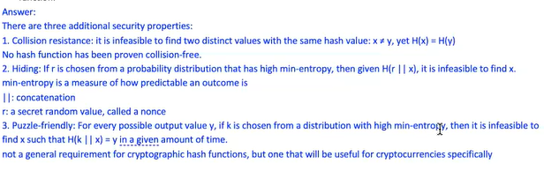
3. Given a dictionary of words (gpg, google, gnu, else, gnome, …) draw the trie for these words.  
   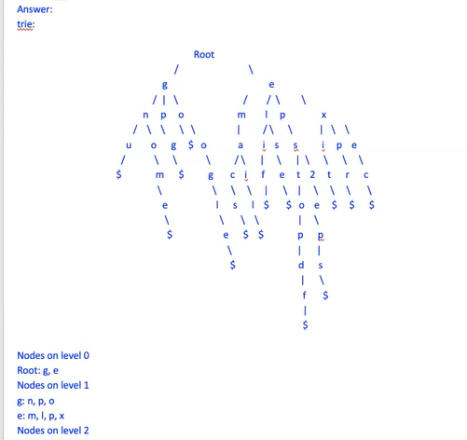  
   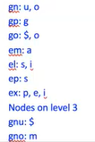  
   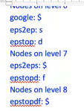
4. Given a dictionary of words…build the compact trie for these words  
   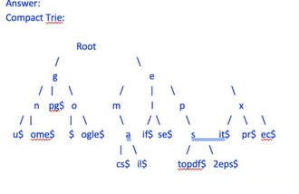[full points]
5. Given one binary text with ten 0’s, comptue the number of comparisons (successful or unsuccessful) made by the brute-force algorithm in searching for the pattern P=01010 I nthe text.   
   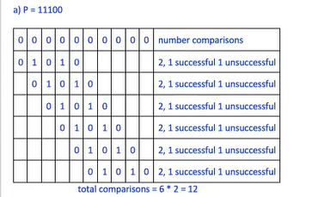
6. Given the text T=rooterotoronto and the pattern P=toro, show how Horspool or Boyer-Moor or Rabin-Karp algo works for searching the pattern P in the text T.  
   [apparently we weren’t supposed to use Rabin Karp]   
   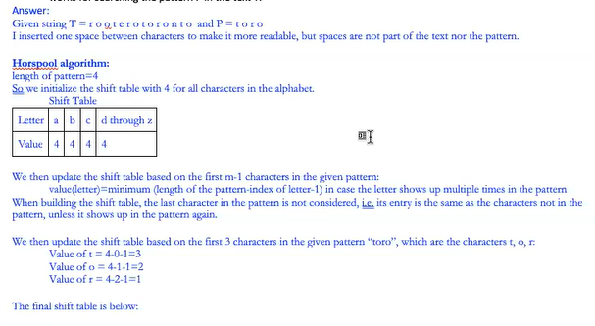  
   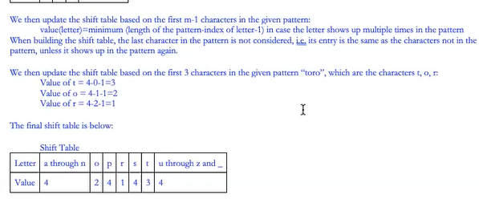  
     
   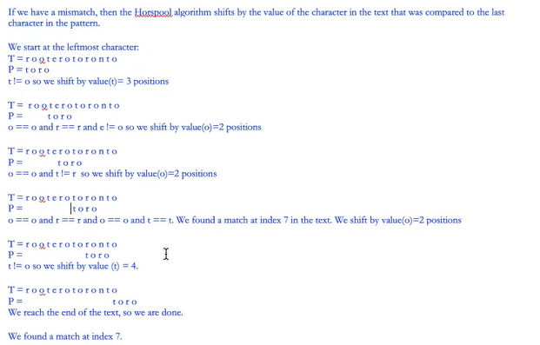  
   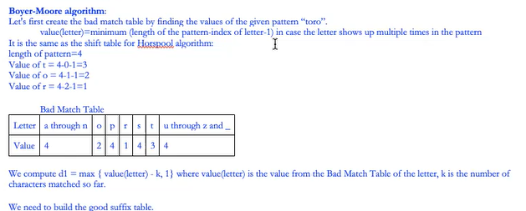  
   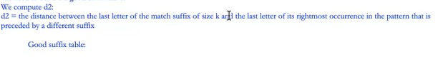  
   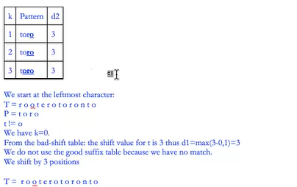  
   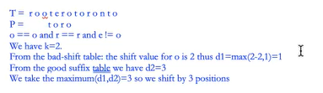  
   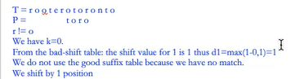  
   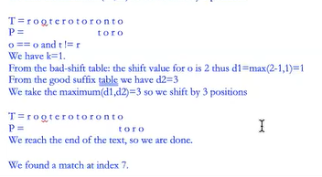
7. 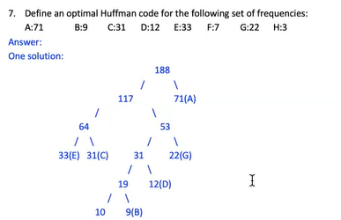  
   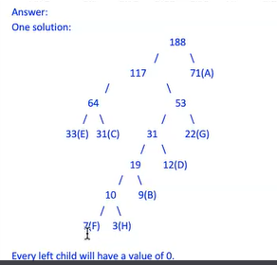
8. Elft off at 10:31